The Battle of Neighborhoods Project

April 14, 2019

1. **Capstone Project - The Battle of the Neighborhoods (Week 2)**

## 1.0.1 Applied Data Science Capstone by IBM/Coursera

* 1. **Introduction: Business Problem**

### In this project we will try to find an optimal location for a restaurant. Specifically, this report will be targeted to stakeholders interested in opening an **restaurant and school** in **New York**, Unite States.

Since there are lots of restaurants in **New York** we will try to detect **locations that are not already crowded with restaurants**. We choose some candidate location in Queens New York city. We want to get the cluster information about the Center Queens, so that we can analyze the cluster. Secondly, it is important that analyze the distribution of the **restaurant type** in each cluster.

### We will use our data science powers to generate a few most promising neighborhoods based on this criteria. Advantages of each area will then be clearly expressed and get the cluster character, so that best possible final location and restaurant type can be chosen by stakeholders.So, we want to explore the center candidate location that belongs to the restaurant type.

* 1. **Data**

Based on definition of our problem, factors that will influence our decision are: * number of exist- ing restaurants in the neighborhood (any type of restaurant) * number of and distance to Italian restaurants in the neighborhood, if any * distance of neighborhood from city center * number of school in the neighborhood (any type of school)

We decided to use regularly spaced grid of locations, centered around city center, to define our neighborhoods.

Following data sources will be needed to extract/generate the required information: * centers of candidate areas will be generated algorithmically and approximate addresses of centers of those areas will be obtained using **Google Maps API reverse geocoding** * number of restaurants and their type and location in every neighborhood will be obtained using **Foursquare API** * number of schools and their type and location in every neighborhood will be obtained using **Foursquare API** * coordinate of New York center will be obtained using **MapBox API** of well known New York Queens location

* 1. **Neighborhood Candidates**

Let’s create latitude & longitude coordinates for centroids of our candidate neighborhoods. We will create a grid of cells covering our area of interest which is aprox. 12x12 killometers centered

around Berlin city center.

Let’s first find the latitude & longitude of Queens New York city center, using specific, well known address and Google Maps geocoding API.

In [1]: import pandas as pd import numpy as np

from bs4 import BeautifulSoup

from matplotlib import pyplot as plt import requests

import folium

from pandas.io.json import json_normalize import matplotlib.cm as cm

import matplotlib.colors as colors from sklearn.cluster import KMeans from geopy.geocoders import Nominatim import json

import seaborn as sns

%matplotlib inline

In [2]: if False:

df = pd.read_csv("./data/data.csv")

# create a geolocator object for each city

In [3]: # The code was removed by Watson Studio for sharing. google_api_key = ""

In [4]: def get_coordinates(api_key, address, verbose=False): try:

url = 'https://maps.googleapis.com/maps/api/geocode/json?key={}&address={}'.form response = requests.get(url).json()

if verbose:

print('Google Maps API JSON result =>', response) results = response['results']

geographical_data = results[0]['geometry']['location'] # get geographical coordi lat = geographical_data['lat']

lon = geographical_data['lng'] return [lat, lon]

except:

return [None, None]

address = "Queens, New York, United States" center = get_coordinates(google_api_key, address)

print('Coordinate of {}: {}'.format(address, center))

Coordinate of Queens, New York, United States: [40.7282239, -73.7948516]

In [ ]: # !pip install shapely # !pip install pyproj

In [5]: #!pip install shapely import shapely.geometry

#!pip install pyproj import pyproj

import math

def lonlat_to_xy(lon, lat):

proj_latlon = pyproj.Proj(proj='latlong',datum='WGS84') proj_xy = pyproj.Proj(proj="utm", zone=33, datum='WGS84') xy = pyproj.transform(proj_latlon, proj_xy, lon, lat) return xy[0], xy[1]

def xy_to_lonlat(x, y):

proj_latlon = pyproj.Proj(proj='latlong',datum='WGS84') proj_xy = pyproj.Proj(proj="utm", zone=33, datum='WGS84') lonlat = pyproj.transform(proj_xy, proj_latlon, x, y) return lonlat[0], lonlat[1]

def calc_xy_distance(x1, y1, x2, y2): dx = x2 - x1

dy = y2 - y1

return math.sqrt(dx*dx + dy*dy)

print('Coordinate transformation check') print(' ')

print('Queens center longitude={}, latitude={}'.format(center[1], center[0])) x, y = lonlat_to_xy(center[1], center[0])

print('Queens center UTM X={}, Y={}'.format(x, y)) lo, la = xy_to_lonlat(x, y)

print('Queens center longitude={}, latitude={}'.format(lo, la))

Coordinate transformation check

-------------------------------

Queens center longitude=-73.7948516, latitude=40.7282239 Queens center UTM X=-5818864.983873131, Y=9842433.386218188

Queens center longitude=-73.79485159999955, latitude=40.728223899998895

### Next step, let’s create a hexagonal grid of cells: we offset every other row, and adjust verti- cal row spacing so that every cell center is equally distant from all it’s neighbors. Besides, let’s visualize the data we have so far: city center location and candidate neighborhood centers.

Now let’s create a grid of area candidates, same spaced, centered around city center and within

~6km from Queens. Our neighborhoods will be defined as circular areas with a radius of 300 meters, so our neighborhood centers will be 600 meters apart.

To accurately calculate distances we need to create our grid of locations in Cartesian 2D co- ordinate system which allows us to calculate distances in meters (not in latitude/longitude de- grees). Then we’ll project those coordinates back to latitude/longitude degrees to be shown on

Folium map. So let’s create functions to convert between WGS84 spherical coordinate system (latitude/longitude degrees) and UTM Cartesian coordinate system (X/Y coordinates in meters).

In [6]: center_x, center_y = lonlat_to_xy(center[1], center[0]) # City center in Cartesian coord

k = math.sqrt(3) / 2 # Vertical offset for hexagonal grid cells x_min = center_x - 6000

x_step = 600

y_min = center_y - 6000 - (int(21/k)*k*600 - 12000)/2 y_step = 600 * k

latitudes = [] longitudes = []

distances_from_center = [] xs = []

ys = []

for i in range(0, int(21/k)): y = y_min + i * y_step

x_offset = 300 if i%2==0 else 0 for j in range(0, 21):

x = x_min + j * x_step + x_offset

distance_from_center = calc_xy_distance(center_x, center_y, x, y) if (distance_from_center <= 6001):

lon, lat = xy_to_lonlat(x, y) latitudes.append(lat) longitudes.append(lon)

distances_from_center.append(distance_from_center) xs.append(x)

ys.append(y)

print(len(latitudes), 'candidate neighborhood centers generated.')

364 candidate neighborhood centers generated.

In [7]: #!pip install folium import folium

In [ ]: map_init = folium.Map(location=center, zoom_start=13)

folium.Marker(center, popup='Queens').add_to(map_init) for lat, lon in zip(latitudes, longitudes):

#folium.CircleMarker([lat, lon], radius=2, color='blue', fill=True, fill_color='blue folium.Circle([lat, lon], radius=300, color='blue', fill=False).add_to(map_init) #folium.Marker([lat, lon]).add_to(map_berlin)

map_init

In [8]: def get_address(api_key, latitude, longitude, verbose=False): try:

url = 'https://maps.googleapis.com/maps/api/geocode/json?key={}&latlng={},{}'. response = requests.get(url).json()

if verbose:

print('Google Maps API JSON result =>', response) results = response['results']

address = results[0]['formatted_address'] return address

except:

return None

addr = get_address(google_api_key, center[0], center[1]) print('Reverse geocoding check')

print(' ')

print('Address of [{}, {}] is: {}'.format(center[0], center[1], addr))

Reverse geocoding check

-----------------------

Address of [40.7282239, -73.7948516] is: Virginia Cheriton, Fresh Meadows, NY 11366, USA

In [9]: print('Obtaining location addresses: ', end='') addresses = []

cou = 0

for lat, lon in zip(latitudes, longitudes):

address = get_address(google_api_key, lat, lon) if address is None:

address = 'NO ADDRESS'

address = address.replace(', USA', '') # We don't need country part of address addresses.append(address)

print(' .', end='') if cou > 5:

break cou += 1

print(' done.')

Obtaining location addresses: done.

In [14]: pd.DataFrame({'Address': addresses,

'Latitude': latitudes[:len(addresses)], 'Longitude': longitudes[:len(addresses)], 'X': xs[:len(addresses)],

'Y': ys[:len(addresses)],

'Distance from center': distances_from_center[:len(address

|  |  |  |  |  |
| --- | --- | --- | --- | --- |
| Out[14]: |  |  | Address | Latitude Longitude \ |
|  | 0 | 93-46 210th Pl, Queens | Village, NY 11428 | 40.716520 -73.751049 |
|  | 1 | 211-30 90th Ct, | Jamaica, NY 11428 | 40.720054 -73.750895 |
|  | 2 | 89-28 213th St, Queens | Village, NY 11427 | 40.723589 -73.750740 |

|  |  |  |  |  |  |
| --- | --- | --- | --- | --- | --- |
| 3 214-46 Whitehall Terrace, | Jamaica, | NY | 11427 | 40.727124 | -73.750586 |
| 4 218-17 Grand Central Pkwy, | Jamaica, | NY | 11427 | 40.730659 | -73.750431 |
| 5 220-24 Hartland Ave, | Jamaica, | NY | 11427 | 40.734194 | -73.750276 |

6 220-72 77th Ave, Flushing, NY 11364 40.737730 -73.750122

|  |  |  |  |
| --- | --- | --- | --- |
| X | Y | Distance | from center |
| 0 -5.820665e+06 | 9.836718e+06 |  | 5992.495307 |
| 1 -5.820065e+06 | 9.836718e+06 |  | 5840.376700 |
| 2 -5.819465e+06 | 9.836718e+06 |  | 5747.173218 |
| 3 -5.818865e+06 | 9.836718e+06 |  | 5715.767665 |
| 4 -5.818265e+06 | 9.836718e+06 |  | 5747.173218 |
| 5 -5.817665e+06 | 9.836718e+06 |  | 5840.376700 |
| 6 -5.817065e+06 | 9.836718e+06 |  | 5992.495307 |

In [ ]: df = pd.DataFrame({'Address': addresses,

'Latitude': latitudes, 'Longitude': longitudes, 'X': xs,

'Y': ys,

'Distance from center': distances_from_center})

df.head(10)

# Get Food Category And School Information

### Get the food category and the school information about Queens center by using FourSquare API.

In [15]: LIMIT = 500 # limit of number of venues returned by Foursquare API radius = 2000 # define radius

CLIENT_ID = "" CLIENT_SECRET = "" VERSION = '20181020'

categoryFood = "4d4b7105d754a06374d81259" categorySchool = "4bf58dd8d48988d13d941735"

In [16]: def getNearbyVenues(name, latitude, longitude, radius=2000, category=""):

url = 'https://api.foursquare.com/v2/venues/search?&radius={}&'.format(radius) expand_infor = "client_id={}&client_secret={}&v={}&ll={},{}&limit={}".format(

CLIENT_ID, CLIENT_SECRET, VERSION, latitude, longitude, LIMIT

)

if category:

category_infor = "&categoryId={}".format(category) else:

category_infor = "" # merge the url

url = url + expand_infor + category_infor

# extract infromation

response = requests.get(url).json() return response

In [ ]: # use the api to get category food

df["CategoryFood"] = df.apply(lambda x: getNearbyVenues(

x["Address"], x["Latitude"], x["Longitude"], category=categoryFood

), axis=1)

In [ ]: # use the api to get school infor

df["CategorySchool"] = df.apply(lambda x: getNearbyVenues(

x["Address"], x["Latitude"], x["Longitude"], category=categorySchool

), axis=1)

# Parse School Information & Food Information

### Next step, we want get the number of food category and the number of school

In [20]: def get_category(x, target="category"): """

parameters:

----------

target: string, default category

Choose target information. Like category, name, location

"""

information = dict( Name = [], Location = [], Category = []

)

x = json.loads(x)

if "response" not in x or "venues" not in x["response"]: return np.nan

for item in x["response"]["venues"]: name = item["name"]

location = (item["location"]["lat"], item["location"]["lng"]) category = item["categories"][0]["name"]

if name and location and category: information["Name"].append(name) information["Location"].append(location) information["Category"].append(category)

if target == "category":

return information["Category"] elif target == "name":

return information["Name"] elif target == "location":

return information["Location"]

elif target in ["all", ""]: return information

In [21]: df["FoodInformation"] = df.CategoryFood.apply(get_category, target="all") df["SchoolInformation"] = df.CategorySchool.apply(get_category, target="all")

In [22]: df.head(2)

Out[22]: Address Latitude Longitude \ 0 93-46 210th Pl, Queens Village, NY 11428 40.716520 -73.751049

1 211-30 90th Ct, Jamaica, NY 11428 40.720054 -73.750895

X Y Distance from center \

|  |  |  |  |
| --- | --- | --- | --- |
| 0 -5.820665e+06 | 9.836718e+06 | 5992.495307 |  |
| 1 -5.820065e+06 | 9.836718e+06 | 5840.376700 |  |

CategoryFood \ 0 {"meta": {"code": 200, "requestId": "5cb1bc00f...

1 {"meta": {"code": 200, "requestId": "5cb1bc00d...

CategorySchool \

1. {"meta": {"code": 200, "requestId": "5caa2f4cd...
2. {"meta": {"code": 200, "requestId": "5caa2f4dd...

FoodInformation \

1. {'Name': ['Dunkin'', 'Dunkin' Donuts/Baskin Ro...
2. {'Name': ['Baskin Robbins', 'Dunkin' Donuts/Ba...

SchoolInformation ... \

1. {'Name': ['Queens Satellite Highschool', 'Path... ...
2. {'Name': ['Queens Satellite Highschool', 'Path... ...

Vegetarian / Vegan Restaurant New American Restaurant Chinese Restaurant \ 0 0 0 5

1 0 0 4

Tapas Restaurant Indian Restaurant Dumpling Restaurant Halal Restaurant \ 0 0 0 0 0

1 0 0 0 1

High School Elementary School Szechuan Restaurant 0 8 0 0

1 7 0 0

[2 rows x 51 columns] In [24]: foodtype = set()

for i in df.FoodInformation: if pd.notna(i):

try:

i = json.loads(i)

except:

foodtype.update(set(i["Category"]))

In [26]: foodtype = pd.Series(list(foodtype))

for column in foodtype[foodtype.str.contains("Restaurant", case=False)]: try:

df[column] = df.FoodInformation.apply(json.loads).apply(lambda x: x["Category"]

if pd.notna(x) else 0)

except:

df[column] = df.FoodInformation.apply(lambda x: x["Category"].count(column)

if pd.notna(x) else 0)

In [27]: schooltype = set()

for i in df.SchoolInformation: if pd.notna(i):

try:

i = json.loads(i) schooltype.update(set(i["Category"]))

except:

schooltype.update(set(i["Category"]))

In [28]: schooltype = pd.Series(list(schooltype))

for column in schooltype[schooltype.str.contains("College|Elementary|School|University" try:

df[column] = df.SchoolInformation.apply(json.loads).apply(lambda x:

x["Category"].count(c

except:

df[column] = df.SchoolInformation.apply(lambda x: x["Category"].count(column) i

In [29]: schooltype

Out[29]: 0 High School

1. Elementary School
2. Cafeteria

dtype: object In [30]: df.head(2)

Out[30]: Address Latitude Longitude \ 0 93-46 210th Pl, Queens Village, NY 11428 40.716520 -73.751049

1 211-30 90th Ct, Jamaica, NY 11428 40.720054 -73.750895

X Y Distance from center \ 0 -5.820665e+06 9.836718e+06 5992.495307

1 -5.820065e+06 9.836718e+06 5840.376700

CategoryFood \

0 {"meta": {"code": 200, "requestId": "5cb1bc00f...

1 {"meta": {"code": 200, "requestId": "5cb1bc00d...

CategorySchool \

1. {"meta": {"code": 200, "requestId": "5caa2f4cd...
2. {"meta": {"code": 200, "requestId": "5caa2f4dd...

FoodInformation \

1. {'Name': ['Dunkin'', 'Dunkin' Donuts/Baskin Ro...
2. {'Name': ['Baskin Robbins', 'Dunkin' Donuts/Ba...

SchoolInformation ... \

1. {'Name': ['Queens Satellite Highschool', 'Path... ...
2. {'Name': ['Queens Satellite Highschool', 'Path... ...

Vegetarian / Vegan Restaurant New American Restaurant Chinese Restaurant \ 0 0 0 5

1 0 0 4

Tapas Restaurant Indian Restaurant Dumpling Restaurant Halal Restaurant \ 0 0 0 0 0

1 0 0 0 1

High School Elementary School Szechuan Restaurant 0 8 0 0

1 7 0 0

[2 rows x 51 columns]

In [ ]: # store data

if False:

df.to_csv("./data/data.csv", index=False)

# Display Information

### Before we cluter the 364 location, we need to explore the school and the food category. We map the information on the map, so that we can explore the food and the school information clearly

In [31]: restaurant = df[

df.columns[df.columns.str.contains("Restaurant", case=False)]

].sum()

restaurant.sort_values().plot(kind="barh", figsize=(12, 8))

plt.title("Total Number Of Different Restaurant Type", loc="left", fontsize=20) plt.show()

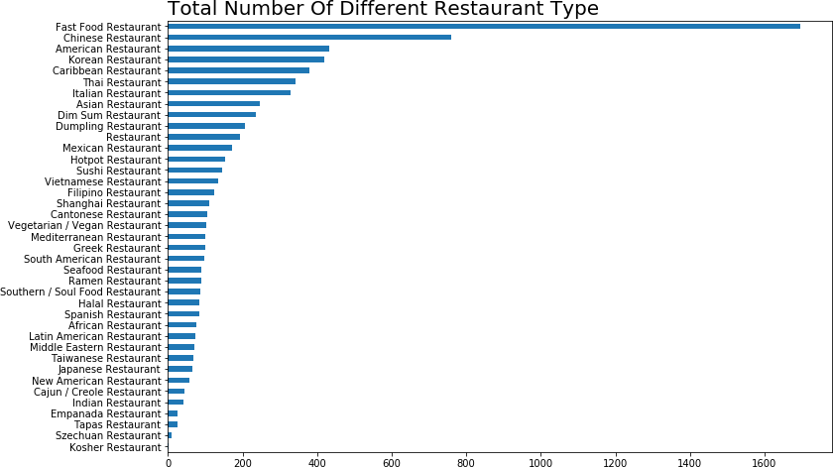

In [33]: school = df[["High School", "Elementary School"]].sum() In [34]: school

Out[34]: High School 4731

Elementary School 32

dtype: int64

In [35]: school.sort_values().plot(kind="bar", figsize=(10, 8), rot=0) plt.title("Total Number Of Different School", loc="left", fontsize=20) plt.show()

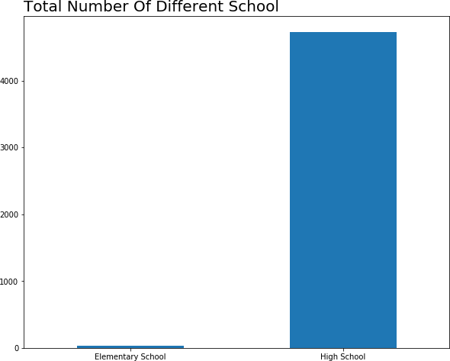

In [36]: df["AllRestarant"] = df[

df.columns[df.columns.str.contains("Restaurant", case=False)]

].sum(axis=1)

In [37]: df["AllSchool"] = df[["High School", "Elementary School"]].sum(axis=1) In [38]: _, ax = plt.subplots(figsize=(10, 5))

sns.distplot(df.AllRestarant, ax=ax, hist_kws={"color":"red", "alpha":.2}, bins=20)

ax.set_title("Distribution About Amount Of Restaurant", loc="left", fontsize=13) ax.set_xlabel("# Restaurant")

plt.show()

/home/jupyterlab/conda/lib/python3.6/site-packages/scipy/stats/stats.py:1713: FutureWarning: Usi return np.add.reduce(sorted[indexer] * weights, axis=axis) / sumval

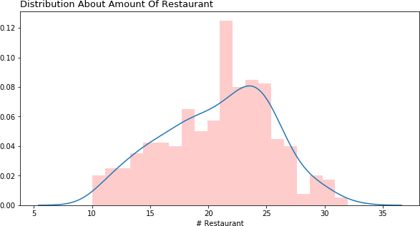

### We can find some information, like that the fast food restaurant is main type in the Queens center, and the second type is the Chinese restaurant. Top 3 restaurant: * Fast Food Restaurant * Chinese Restaurant * American Restaurant

Besides, there are between 20 and 25 restaurants at most candidate location.

In [39]: _, ax = plt.subplots(figsize=(10, 5))

sns.distplot(df.AllSchool, ax=ax, hist_kws={"color":"red", "alpha":.2}, bins=20)

ax.set_title("Distribution About Amount Of School", loc="left", fontsize=13) ax.set_xlabel("# School")

plt.show()

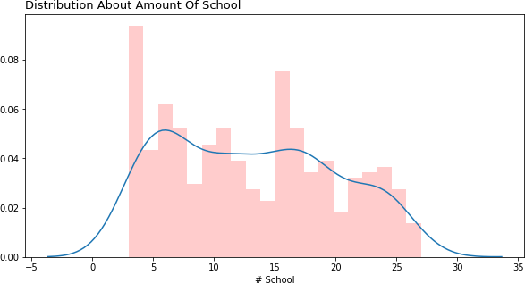

* + 1. **School Information**

### There are two type of schools, elementary school and high school. And hight school is the major type. Most candidate location has less five schools.

* 1. **Map Information**

In [41]: foodlocation = []

for i in df["FoodInformation"]: if pd.notna(i):

try:

i = json.loads(i) foodlocation += i["Location"]

except:

foodlocation += i["Location"]

In [42]: center

Out[42]: [40.7282239, -73.7948516]

In [60]: map_init = folium.Map(location=center, zoom_start=13.48, tiles="CartoDB dark_matter") folium.Marker(center, popup='Queens Food').add_to(map_init)

# # add markers to map

# label = '{}'.format(addr)

# label = folium.Popup(label, parse_html=True)

# # folium.Marker(center, popup=label).add_to(map_init)

for lat, lon, sc, ar in zip(df["Latitude"], df["Longitude"], df["AllSchool"], df["AllRe # if sc != 0:

# folium.CircleMarker([lat, lon], radius=sc * .2, fill=True,

# fill_color="blue", fill_opacity=.3).add_to(map_init) if ar != 0:

folium.CircleMarker([lat, lon], radius=ar * .2, fill=True, color="red", fill_color="red", fill_opacity=.8).add_to(map_init)

# label = 'School:{}\nRestaurant:{}'.format(sc, ar) # label = folium.Popup(label, parse_html=True)

# folium.Marker([lat, lon], popup=label).add_to(map_init)

map_init

Out[60]: <folium.folium.Map at 0x7fd054349a58>

In [58]: map_init = folium.Map(location=center, zoom_start=13.48, tiles="CartoDB dark_matter") folium.Marker(center, popup='Queens Schools').add_to(map_init)

# # add markers to map

# label = '{}'.format(addr)

# label = folium.Popup(label, parse_html=True)

# # folium.Marker(center, popup=label).add_to(map_init)

for lat, lon, sc, ar in zip(df["Latitude"], df["Longitude"], df["AllSchool"], df["AllRe if sc != 0:

folium.CircleMarker([lat, lon], radius=sc * .2, fill=True, color="blue", fill_color="blue", fill_opacity=.8).add_to(map_init)

# if ar != 0:

# folium.CircleMarker([lat, lon], radius=ar * .2, fill=True, color="red", # fill_color="red", fill_opacity=.8).add_to(map_init) # label = 'School:{}\nRestaurant:{}'.format(sc, ar)

# label = folium.Popup(label, parse_html=True)

# folium.Marker([lat, lon], popup=label).add_to(map_init)

map_init

Out[58]: <folium.folium.Map at 0x7fd054a519b0> In [61]: df.columns

Out[61]: Index(['Address', 'Latitude', 'Longitude', 'X', 'Y', 'Distance from center', 'CategoryFood', 'CategorySchool', 'FoodInformation', 'SchoolInformation', 'Thai Restaurant', 'Mediterranean Restaurant', 'Cantonese Restaurant', 'Sushi Restaurant', 'Latin American Restaurant', 'Mexican Restaurant', 'Southern / Soul Food Restaurant',

'American Restaurant', 'Filipino Restaurant', 'Cajun / Creole Restaurant', 'Korean Restaurant',

'Fast Food Restaurant', 'Spanish Restaurant', 'Caribbean Restaurant', 'Italian Restaurant', 'Vietnamese Restaurant', 'Taiwanese Restaurant', 'Asian Restaurant', 'South American Restaurant', 'Ramen Restaurant', 'Middle Eastern Restaurant', 'Seafood Restaurant', 'Hotpot Restaurant', 'Shanghai Restaurant', 'Japanese Restaurant', 'Empanada Restaurant', 'Greek Restaurant', 'Restaurant', 'Dim Sum Restaurant',

'Kosher Restaurant', 'African Restaurant',

'Vegetarian / Vegan Restaurant', 'New American Restaurant', 'Chinese Restaurant', 'Tapas Restaurant', 'Indian Restaurant', 'Dumpling Restaurant', 'Halal Restaurant', 'High School', 'Elementary School', 'Szechuan Restaurant', 'AllRestarant', 'AllSchool'],

dtype='object')

In [62]: train_data = df.drop(["Address", "CategoryFood", "Latitude" ,

'Longitude', 'X', 'Y', 'Fast Food Restaurant', "CategorySchool", "FoodInformation", "SchoolInformation", 'High School'], axis=1).copy()

In [63]: train_data.head(2)

Out[63]: Distance from center Thai Restaurant Mediterranean Restaurant \ 0 5992.495307 0 0

1 5840.376700 0 0

Cantonese Restaurant Sushi Restaurant Latin American Restaurant \ 0 0 2 1

1 0 2 1

Mexican Restaurant Southern / Soul Food Restaurant American Restaurant \ 0 2 1 0

1 2 1 0

Filipino Restaurant ... New American Restaurant Chinese Restaurant \ 0 0 ... 0 5

1 0 ... 0 4

Tapas Restaurant Indian Restaurant Dumpling Restaurant Halal Restaurant \ 0 0 0 0 0

1 0 0 0 1

Elementary School Szechuan Restaurant AllRestarant AllSchool 0 0 0 26 8

1 0 0 24 7

[2 rows x 42 columns]

# Scale the data

The feature Distance from center are large value, so we use the StandardScaler method to scale the value

In [64]: from sklearn.preprocessing import Normalizer, normalize, StandardScaler, MinMaxScaler, In [66]: norm = StandardScaler()

train_data[["Distance from center", "AllRestarant"]] = \

norm.fit_transform(train_data[["Distance from center", "AllRestarant"]])

/home/jupyterlab/conda/lib/python3.6/site-packages/sklearn/preprocessing/data.py:625: DataConver return self.partial_fit(X, y)

/home/jupyterlab/conda/lib/python3.6/site-packages/sklearn/base.py:462: DataConversionWarning: return self.fit(X, **fit_params).transform(X)

In [67]: train_data.head(2)

Out[67]: Distance from center Thai Restaurant Mediterranean Restaurant \ 0 1.400281 0 0

1 1.292965 0 0

Cantonese Restaurant Sushi Restaurant Latin American Restaurant \ 0 0 2 1

1 0 2 1

Mexican Restaurant Southern / Soul Food Restaurant American Restaurant \ 0 2 1 0

1 2 1 0

Filipino Restaurant ... New American Restaurant Chinese Restaurant \ 0 0 ... 0 5

1 0 ... 0 4

Tapas Restaurant Indian Restaurant Dumpling Restaurant Halal Restaurant \ 0 0 0 0 0

1 0 0 0 1

Elementary School Szechuan Restaurant AllRestarant AllSchool 0 0 0 1.098931 8

1 0 0 0.673840 7

[2 rows x 42 columns]

# Reduce Dimension

### We can create the principle component.

In [68]: from sklearn.decomposition import PCA In [69]: pca = PCA(n_components=6)

pca.fit(train_data)

Out[69]: PCA(copy=True, iterated_power='auto', n_components=6, random_state=None, svd_solver='auto', tol=0.0, whiten=False)

In [70]: pca.explained_variance_ratio_

Out[70]: array([0.70486607, 0.09790623, 0.05607952, 0.03650603, 0.02465284,

0.01479757])

In [71]: def pca_results(good_data, pca):

'''

Create a DataFrame of the PCA results

Includes dimension feature weights and explained variance Visualizes the PCA results

'''

# Dimension indexing

dimensions = dimensions = ['Dimension {}'.format(i) for i in range(1,len(pca.compon

# PCA components

components = pd.DataFrame(np.round(pca.components_, 4), columns = list(good_data.ke

components.index = dimensions

# PCA explained variance

ratios = pca.explained_variance_ratio_.reshape(len(pca.components_), 1) variance_ratios = pd.DataFrame(np.round(ratios, 4), columns = ['Explained Variance' variance_ratios.index = dimensions

# Create a bar plot visualization

fig, ax = plt.subplots(figsize = (14,8))

# Plot the feature weights as a function of the components components.plot(ax = ax, kind = 'bar'); ax.set_ylabel("Feature Weights") ax.set_xticklabels(dimensions, rotation=0)

# Display the explained variance ratios

for i, ev in enumerate(pca.explained_variance_ratio_):

ax.text(i-0.40, ax.get_ylim()[1] + 0.05, "Explained Variance\n %.4f"%(ev))

# Return a concatenated DataFrame

return pd.concat([variance_ratios, components], axis = 1) In [72]: pca_result = pca_results(train_data, pca)

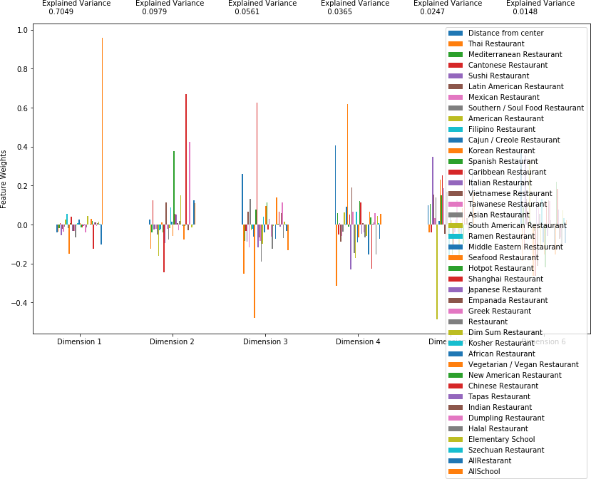

In [73]: g = sns.JointGrid("Dimension 1", "Dimension 2", height=10, data=

pd.DataFrame(np.round(pca.transform(train_data), 4), columns = pca_result.index.values))

g = g.plot_joint(sns.kdeplot, cmap="Blues", shade=True) g = g.plot_marginals(sns.kdeplot, shade=True)

/home/jupyterlab/conda/lib/python3.6/site-packages/scipy/stats/stats.py:1713: FutureWarning: Usi return np.add.reduce(sorted[indexer] * weights, axis=axis) / sumval

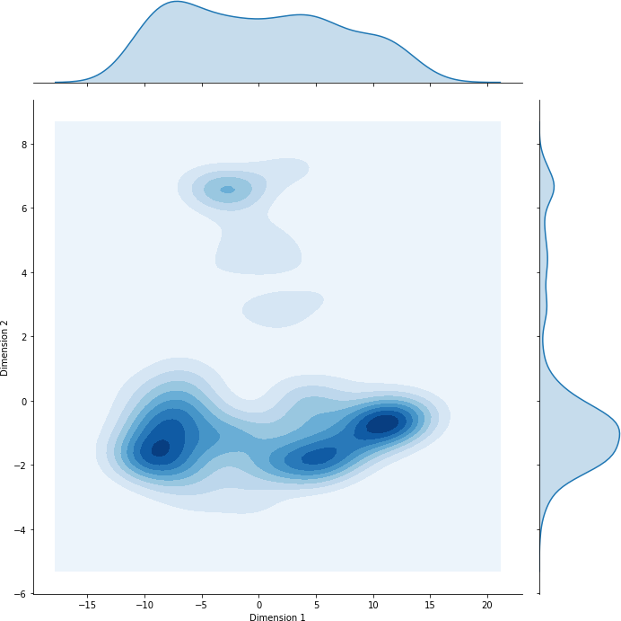

# Create Cluster

### We want to explore the number of cluster. So we use the KMeans algorithm to create model. Now we must check out how many clusters in the 364 candidate locations. In early step, we find that maybe there are four cluster about the two main principle.

In [74]: from sklearn.metrics import silhouette_samples, silhouette_score import matplotlib.pyplot as plt

#import matplotlib.cm as cm

import numpy as np

In [75]: from sklearn.model_selection import train_test_split

In [76]: train, test = train_test_split(pca.transform(train_data)[:, :2], test_size=.02, random_

In [77]: def create_cluster(data, n, validate_data=None): clusterer = KMeans(random_state=42, n_clusters=n)

clusterer.fit(data)

preds = clusterer.predict(data)

# TODOcluseter Center

centers = clusterer.cluster_centers_

# TODOpredict

sample_preds = clusterer.predict(validate_data)

# TODOmean silhouette coefficient score = silhouette_score(data, preds)

print("The %d clusters of KMeans, the score is %.3f" % (n, score)) return clusterer, centers, preds, score, sample_preds

In [86]: k = []

tem = [] final_score = 0

for i in range(2, 10):

_, centers, preds, score, validate_preds = create_cluster(train, i, test) k.append(i)

tem.append(score)

if final_score == 0 or final_score <= score: final_score = score

final_preds = preds final_centers = centers sample_preds = validate_preds

|  |  |  |  |  |  |  |  |  |
| --- | --- | --- | --- | --- | --- | --- | --- | --- |
| The | 2 | clusters | of | KMeans, | the | score | is | 0.558 |
| The | 3 | clusters | of | KMeans, | the | score | is | 0.515 |
| The | 4 | clusters | of | KMeans, | the | score | is | 0.568 |
| The | 5 | clusters | of | KMeans, | the | score | is | 0.551 |
| The | 6 | clusters | of | KMeans, | the | score | is | 0.559 |
| The | 7 | clusters | of | KMeans, | the | score | is | 0.496 |
| The | 8 | clusters | of | KMeans, | the | score | is | 0.481 |
| The | 9 | clusters | of | KMeans, | the | score | is | 0.457 |

In [79]: def cluster_results(reduced_data, preds, centers, pca_samples): '''

Visualizes the PCA-reduced cluster data in two dimensions

Adds cues for cluster centers and student-selected sample data '''

predictions = pd.DataFrame(preds, columns = ['Cluster']) plot_data = pd.concat([predictions, pd.DataFrame(reduced_data,

columns=["Dimension 1", "Dimension

# Generate the cluster plot

fig, ax = plt.subplots(figsize = (14,8))

# Color map

cmap = cm.get_cmap('gist_rainbow')

# Color the points based on assigned cluster for i, cluster in plot_data.groupby('Cluster'):

cluster.plot(ax = ax, kind = 'scatter', x = 'Dimension 1', y = 'Dimension 2', \ color = cmap((i)*1.0/(len(centers)-1)), label = 'Cluster %i'%(i),

# Plot centers with indicators for i, c in enumerate(centers):

ax.scatter(x = c[0], y = c[1], color = 'white', edgecolors = 'black', \ alpha = 1, linewidth = 2, marker = 'o', s=200);

ax.scatter(x = c[0], y = c[1], marker='$%d$'%(i), alpha = 1, s=100);

# Plot transformed sample points

ax.scatter(x = pca_samples[:,0], y = pca_samples[:,1], \

s = 150, linewidth = 4, color = 'black', marker = 'x');

# Set plot title

ax.set_title("Cluster Learning on PCA-Reduced Data - Centroids Marked by Number\n \ Transformed Sample Data Marked by Black Cross");

In [80]: cluster_results(train, final_preds, final_centers, test)

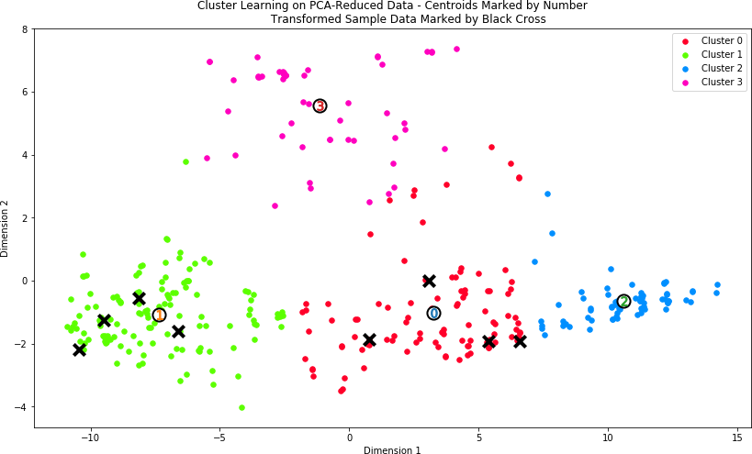

In [81]: kclusters = 4

clusterer = KMeans(n_clusters=kclusters, random_state=42) cluster_labels = clusterer.fit_predict(pca.transform(train_data)) train_data["Cluster"] = cluster_labels

In [82]: train_data.head(2)

Out[82]: Distance from center Thai Restaurant Mediterranean Restaurant \ 0 1.400281 0 0

1 1.292965 0 0

Cantonese Restaurant Sushi Restaurant Latin American Restaurant \ 0 0 2 1

1 0 2 1

Mexican Restaurant Southern / Soul Food Restaurant American Restaurant \ 0 2 1 0

1 2 1 0

Filipino Restaurant ... Chinese Restaurant Tapas Restaurant \ 0 0 ... 5 0

1 0 ... 4 0

Indian Restaurant Dumpling Restaurant Halal Restaurant \ 0 0 0 0

1 0 0 1

Elementary School Szechuan Restaurant AllRestarant AllSchool Cluster 0 0 0 1.098931 8 2

1 0 0 0.673840 7 2

[2 rows x 43 columns]

# Results and Discussion

In [88]: map_init = folium.Map(location= center, zoom_start=13, tiles="CartoDB dark_matter") import matplotlib.colors as colors

# set color scheme for the clusters x = np.arange(kclusters)

colors_array = cm.rainbow(np.linspace(0, 1, kclusters)) rainbow = [colors.rgb2hex(i) for i in colors_array]

# add markers to the map markers_colors = []

for lat, lon, cluster in zip(df['Latitude'], df['Longitude'], train_data['Cluster']): folium.CircleMarker(

[lat, lon], radius=3,

# popup=label, color=rainbow[cluster-1], fill=True, fill_color=rainbow[cluster-1], fill_opacity=0.7).add_to(map_init)

map_init

Out[88]: <folium.folium.Map at 0x7fd050111c88> In [84]: df["Cluster"] = train_data["Cluster"]

In [89]: show_data = df.loc[train_data["Cluster"]== 0]

fig, ax = plt.subplots(figsize=(12, 8), ncols=2, nrows=1) restaurant = show_data[

show_data.columns[show_data.columns.str.contains("Restaurant", case=False)]

].sum()

restaurant.nlargest(15).sort_values().plot(kind="barh", ax=ax[0]) ax[0].set_title("Top15 Restaurant", loc="left", fontsize=15) restaurant.nsmallest(15).plot(kind="barh", ax=ax[1]) ax[1].tick_params(labelleft=False, labelright=True, left=False, right=True) ax[1].set_title("Bottom15 Restaurant", loc="right", fontsize=15)

fig.suptitle("Total Number Of Different Restaurant Type In Cluster I", fontsize=20) plt.show()

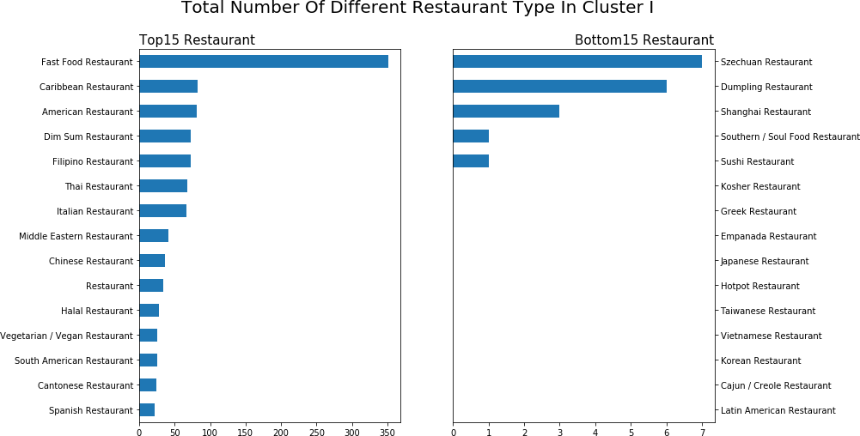

## Cluster I Candidate Location

### Fast Restaurant is main type

* + - * Western Restaurants have the largest market
      * Eastern Restaurants have the few market

In [90]: show_data = df.loc[train_data["Cluster"]== 1]

fig, ax = plt.subplots(figsize=(12, 8), ncols=2, nrows=1) restaurant = show_data[

show_data.columns[show_data.columns.str.contains("Restaurant", case=False)]

].sum()

restaurant.nlargest(15).sort_values().plot(kind="barh", ax=ax[0]) ax[0].set_title("Top15 Restaurant", loc="left", fontsize=15) restaurant.nsmallest(15).plot(kind="barh", ax=ax[1]) ax[1].tick_params(labelleft=False, labelright=True, left=False, right=True) ax[1].set_title("Bottom15 Restaurant", loc="right", fontsize=15)

fig.suptitle("Total Number Of Different Restaurant Type In Cluster II", fontsize=20) plt.show()

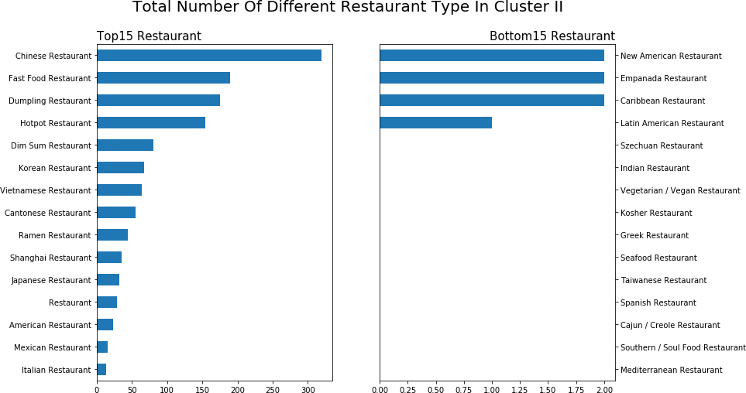

## Cluster II Candidate Location

### Chinese Restaurant is main type

* + - * Asian Restaurants have the largest market, like Chinese Breakfast restaurant
      * Western Restaurants have the few market

In [91]: show_data = df.loc[train_data["Cluster"]== 2]

fig, ax = plt.subplots(figsize=(12, 8), ncols=2, nrows=1) restaurant = show_data[

show_data.columns[show_data.columns.str.contains("Restaurant", case=False)]

].sum()

restaurant.nlargest(15).sort_values().plot(kind="barh", ax=ax[0]) ax[0].set_title("Top15 Restaurant", loc="left", fontsize=15) restaurant.nsmallest(15).plot(kind="barh", ax=ax[1]) ax[1].tick_params(labelleft=False, labelright=True, left=False, right=True) ax[1].set_title("Bottom15 Restaurant", loc="right", fontsize=15)

fig.suptitle("Total Number Of Different Restaurant Type In Cluster III", fontsize=20) plt.show()

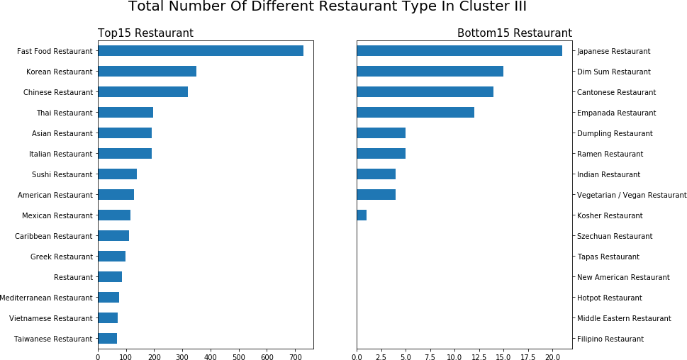

## Cluster III Candidate Location

### Fast Food Restaurant is main type

* + - * The candidate location has mixture restaurant type.Asian Restaurants and western restau- rant are same important type
      * the Asian restaurant is lack of variety. The candidate location is a good choice to open an Asian restaurant. Maybe the Chinese Breakfast restaurant is a good idea

In [92]: show_data = df.loc[train_data["Cluster"]== 3]

fig, ax = plt.subplots(figsize=(12, 8), ncols=2, nrows=1) restaurant = show_data[

show_data.columns[show_data.columns.str.contains("Restaurant", case=False)]

].sum()

restaurant.nlargest(15).sort_values().plot(kind="barh", ax=ax[0]) ax[0].set_title("Top15 Restaurant", loc="left", fontsize=15) restaurant.nsmallest(15).plot(kind="barh", ax=ax[1]) ax[1].tick_params(labelleft=False, labelright=True, left=False, right=True) ax[1].set_title("Bottom15 Restaurant", loc="right", fontsize=15)

fig.suptitle("Total Number Of Different Restaurant Type In Cluster IV", fontsize=20) plt.show()

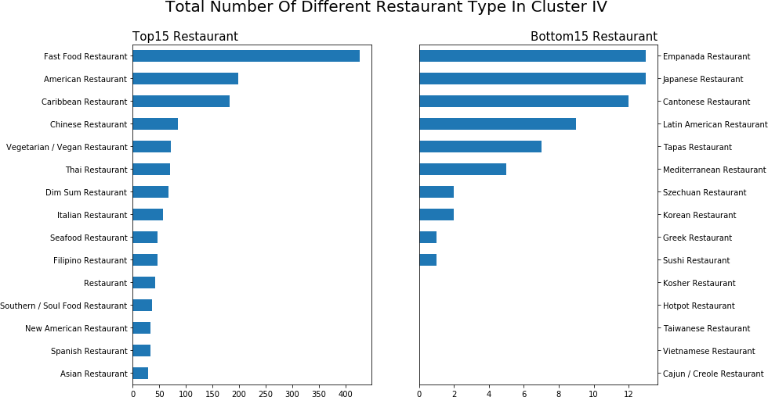

## Cluster IV Candidate Location

### Fast Food Restaurant is main type

* + - * The candidate location has mixture restaurant type.Asian Restaurants and western restau- rant are same important type
      * the Asian restaurant is lack of variety. The candidate location is a good choice to open an Asian restaurant. But the southeastern Asian restaurant is not a good idea